Major Project Synopsis
On
DRAWING & WRITING MACHINE
By
CHIRAG (20622008)
AJAY KUMAR (20622004)
YOGENDRA KATUWAL (10621618)

Under the Guidance of
Ms. CARYNTHIA KHARKONGOR



2024-2025

Delhi Skill and Entrepreneurship University
DSEU Rajokri Campus, Rajokri
Delhi-110038
Introduction
This project aims to create a machine which can generate any type of drawing by converting digital input from the software to physical drawings. This project can generate very accurate and detailed artworks also it can be able to write text which makes the project as multifunctional system.

Problem Statement
The method of creating physical artworks includes efforts and artistic skill which cause difficulties, also manual drawing and writing can be time consuming and can not be perfect and accurate. The Drawing and Writing machine project resolve these issues by providing automating and efficiently processing the accurate artworks in small time of period.

Aim / Objective
The objective of the project is to create a machine that involves:
- To generate an algorithm that process the machine for how to work.
- To converts the digital input from the software to physical output to draw on paper.
- To controls the motors to move all directions using the iron rods.
- To gives the precise and accurate artwork or writing text.

Hardware and Software requirements
Hardware:
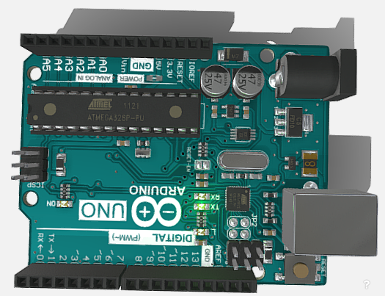
- Arduino uno: Microcontroller to control all operations. Arduino UNO is a microcontroller board based on the ATmega328P. It has 14 digital input/output pins (of which 6 can be used as PWM outputs), 6 analog inputs, a 16 MHz ceramic resonator, a USB connection, a power jack, an ICSP header and a reset button. It contains everything needed to support the microcontroller [1].

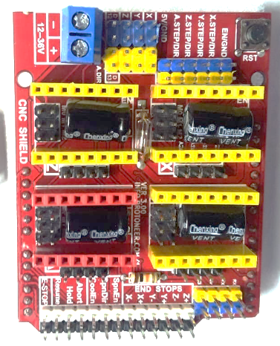
- CNC Shield: CNC shield V3 is an open-source hardware used to control stepper motors. Allows to control 4 motors simultaneously. It uses removable A4988 stepper controls. Stepper motors are connected via 4-pin connectors. Its supply voltage is 12-36 V [2].

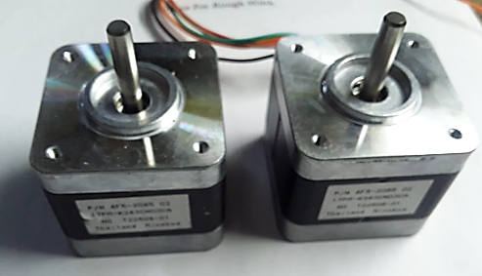
- (2) Stepper motor: It is an electrical motor that rotates in a series of small angular steps, instead of continuously. Stepper motors are a type of digital actuator. It converts electrical energy to mechanical energy [3].

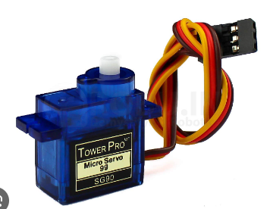
- (1) Servo motor: Servo motor is a type of motor that can rotate with great precision. It can rotate any specific angle and gives feedback of its current position [4].
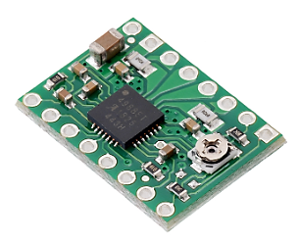
- A4988 stepper motor driver: This breakout board for Allegro’s A4988 microstepping bipolar stepper motor driver features adjustable current limiting, over-current and over-temperature protection, and five different microstep resolutions (down to 1/16-step). It operates from 8 V to 35 V [5].

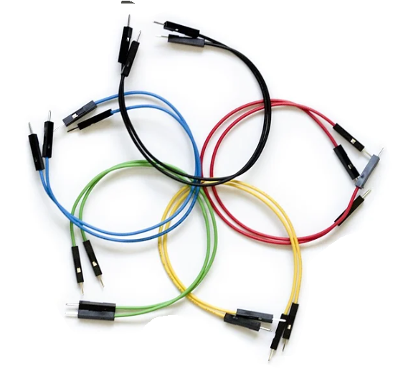
- Jumper wires: Jumper wires are simply wires that have connector pins at each end, allowing them to be used to connect two points to each other without soldering. Jumper wires are typically used with breadboards [6].

- Frame and iron rods
- 12V battery
- Laptop or computer
  - Minimum ram 4GB to handle machine learning algorithm.
  - SSD storage with at least 256GB capacity for fast data access and response
  - Multi-core processor with at least 2.0 GHz
  - Stable internet connection for accessing online resources, updates, and support.

Software:
- Windows 10 or later, macOS or Linux
- Support for major web browsers such as Google Chrome, Firefox, Microsoft Edge etc.
- Software: Inkscape or Universal G-code sender
- Programming Language: “GRBL firmware” for coding instructions for the microcontroller.

Conclusion
This project provides benefits such as:
- Increased efficiency and speed: Automating drawing tasks can save time and effort.
- Improved accuracy and precision: Machines can create complex details more consistently than manual drawing.
- Accessibility and control: The drawing machine can control the stroke of the pen for better artwork.

References & Bibliography
- https://docs.arduino.cc/hardware/uno-rev3/
- https://shorturl.at/FR048
- https://en.wikipedia.org/wiki/Stepper_motor
- https://en.wikipedia.org/wiki/Servomotor
- https://www.pololu.com/product/1182
- https://blog.sparkfuneducation.com/what-is-jumper-wire

